## Listings price change due to Covid-19

This analysis is focused on the comparison of listing’s price before and after Covid-19 pandemic. In 2020, the average price of listings is xxxx. In 2021, the average price of listings is xxxx. From these two data, it is easy to tell the 2021 price of listings is much lower than the price in 2020. There is a huge Covid-19 outbreak impact on tourism. The host has to use a low price to attract guests.

To analyze this, the prices of the same listing in 2020 and 2021 were compared. There are 32342 listings that have lower prices in 2021 compared with the prices in 2020. However, there are 25141 listings that have higher prices in 2021 compared with the prices in 2020. To know more details about the decreased prices of listing, the distribution of the price change is plotted.

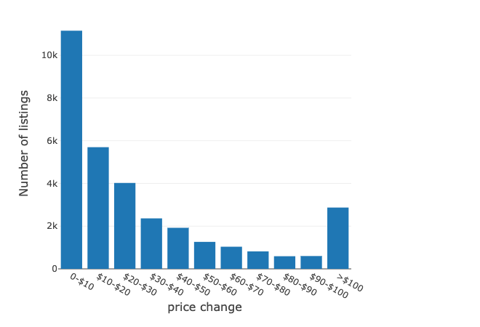

From this graph, it is obvious that over 10k listings have a small price change which is less than $10. There are around 6k, 4k, 2k listing have the $10-$20, $20-$30, $30-$40

